VirtualBox and Ubuntu Server Installation Tutorial

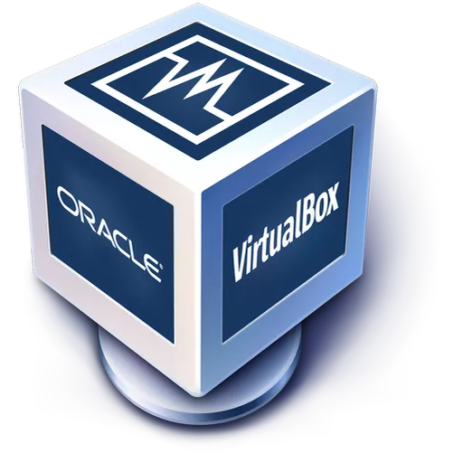

Jorge Arcoya López

2ºYear of DAW Bil

INDEX

***Introduction 3***

***System Requirements 3***

***VirtualBox Installation 5***

***Ubuntu Server Installation 9***

***Installation of the Graphical Interface 20***

***Bibliografía 25***

Introduction

VirtualBox is an application that allows you to install different operating systems using ISO images of the operating system you want to install, where you can specify different specifications for the operating system you want to install.

The main problem that VirtualBox solves is that if you want to test things or perform some tasks and you don't want to do it on your computer in case something goes wrong, you can do it in VirtualBox without fearing that your computer will be damaged.

System Requirements

VirtualBox is a virtualisation software developed by Oracle for x86/amd64 architectures.

The operating systems supported by VirtualBox are

* GNU/Linux
* Mac OS X
* OS/2 Warp
* Microsoft Windows
* Solaris/OpenSolaris

And the operating systems that VirtualBox can virtualise are:

* FreeBSD
* GNU/Linux
* OpenBSD
* OS/2 Warp
* Windows
* Solaris
* MS-DOS
* Android

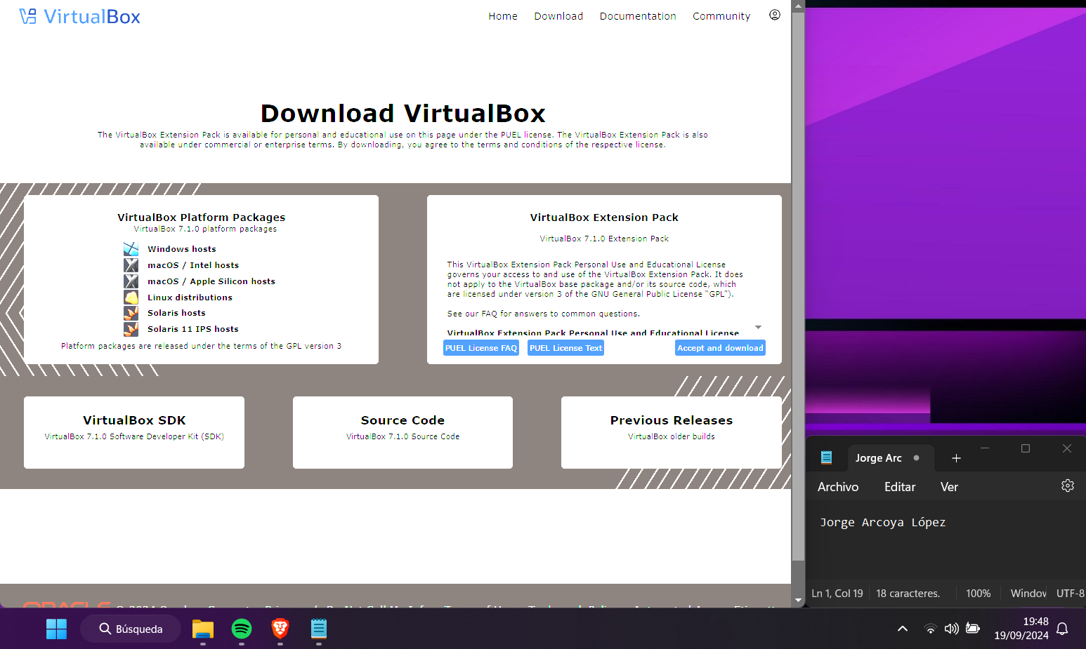To download VirtualBox, go to the VirtualBox website, https://www.virtualbox.org/,then go to the 'Download' section and download the version for the operating system you are using, in my case Windows.

VirtualBox Installation

After downloading VirtualBox from its homepage, open the installer and click the ‘next’ button. Image 1 shows how.

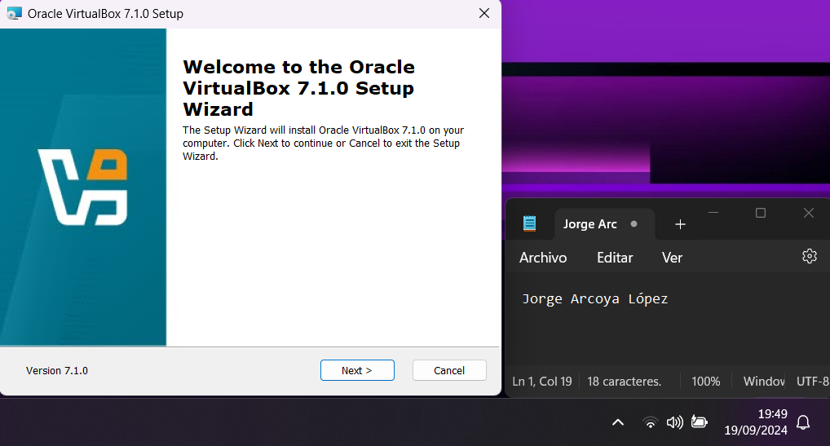

Picture 1 Start of Installation

In the next screen you have to choose the VirtualBox features to be installed, once you have chosen them, click on the ‘Next’ option. Image 2 shows the process.

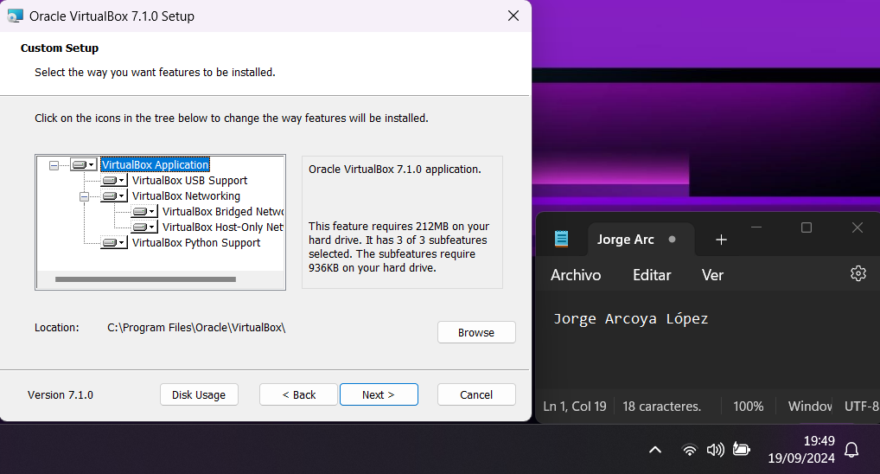

Picture 2 Select the features

After that the installer warns that the installation will reset the network connections and asks if you want to continue with the installation, then click ‘Yes’. Picture 3 shows how.

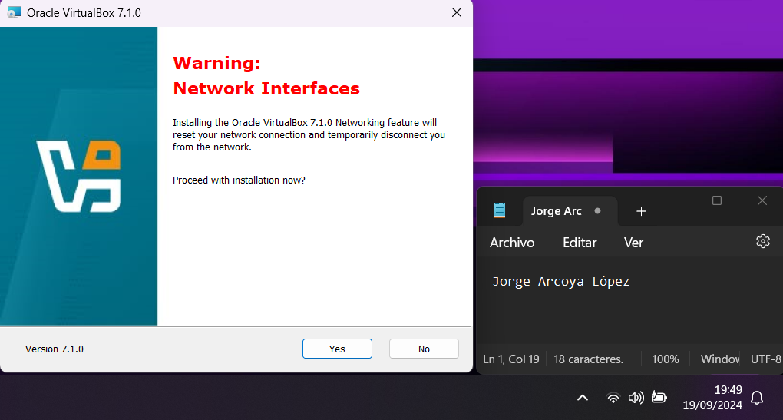

Picture 3 Networks Interfaces

Then, the installer indicates that VirtualBox needs the Python Core package and that if you want to proceed with the installation, click ‘Yes’ again. Image 4 shows you how to do this.

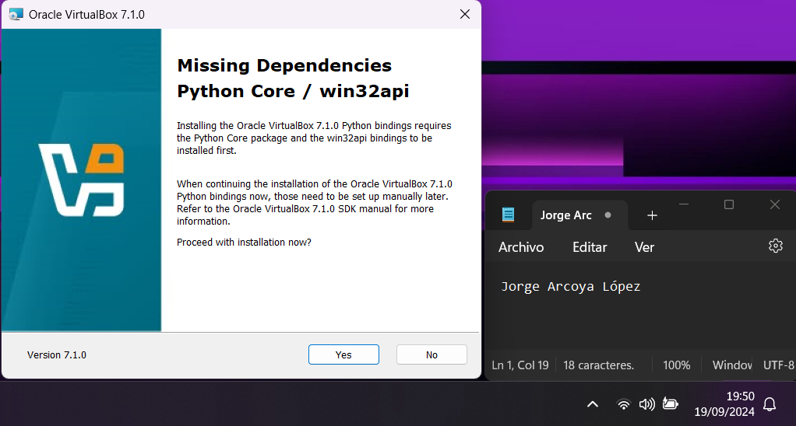

Picture 4 Phyton Core

The next page is to choose if you want a shortcut to appear in the navigation bar, on the desktop among others, choose the options you want and click ‘Next’. Image 5 shows an example.

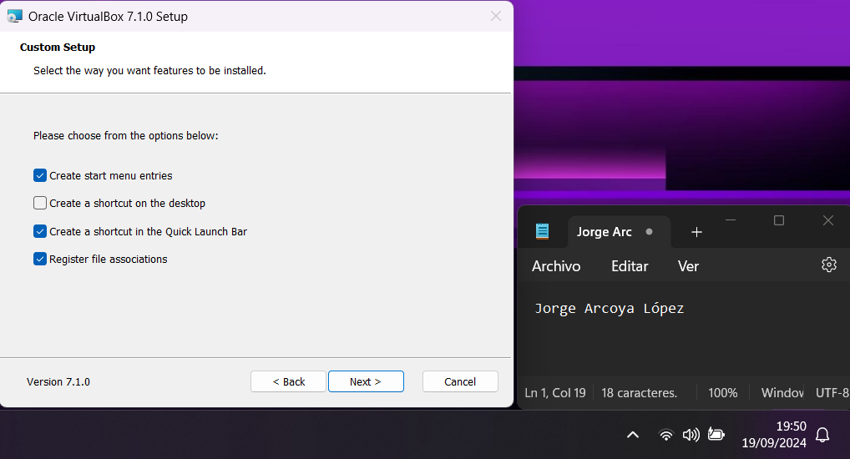

Picture 5 Custom Setup

Following is the installer page where you have to click ‘Install’ to start the installation of VirtualBox. Picture 6 shows how to proceed.

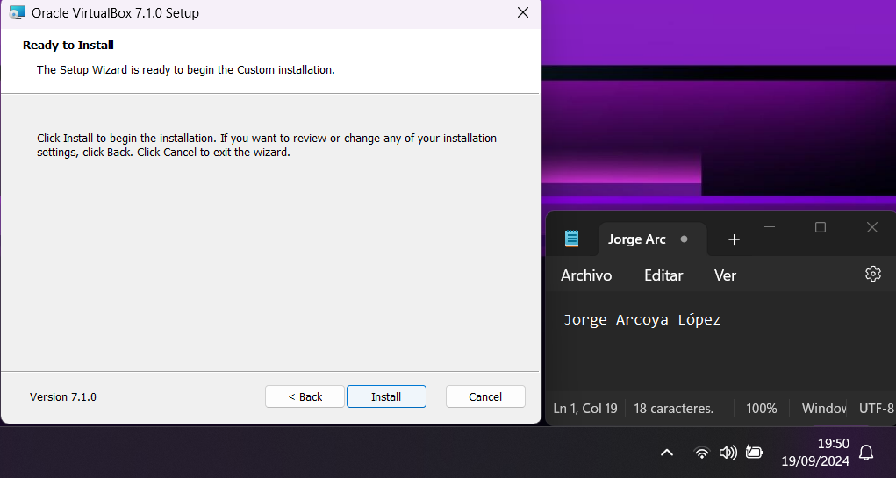

Picture 6 Ready to Install

Once the installation is finished, a page will appear saying that the installation is complete, if you check the option that comes when you press the ‘Finish’ button, the Virtual Box will start. Image 7 shows the above explained.

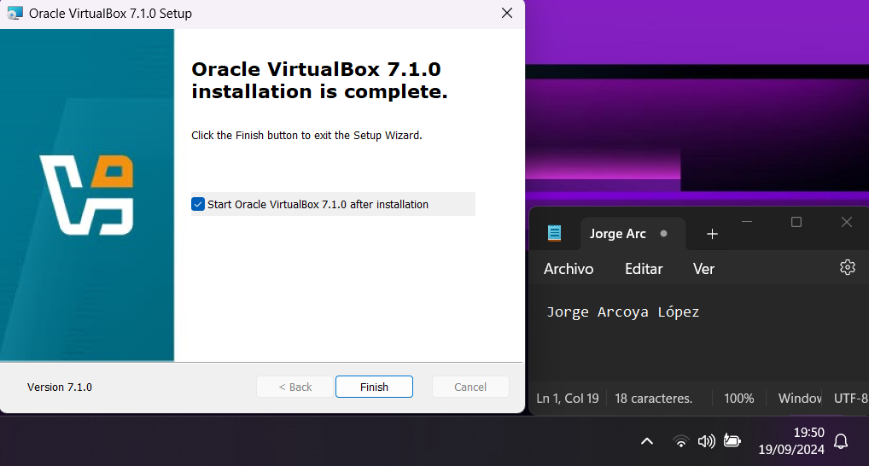

Picture 7 Installation Complete

Ubuntu Server Installation

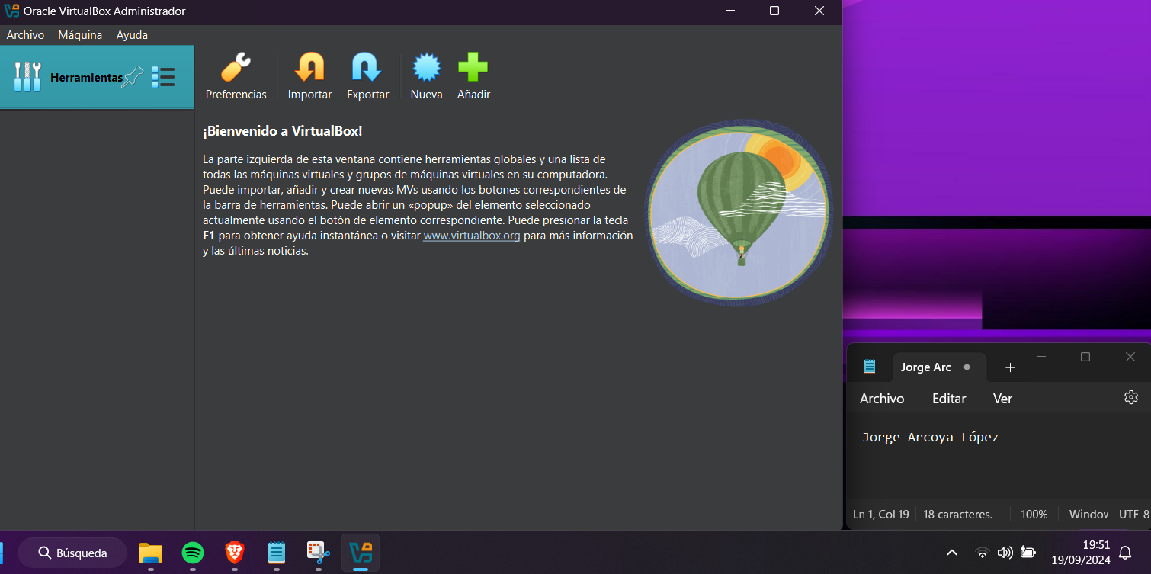After installing VirtualBox, to install the Ubuntu server, click on the blue button in the middle of the top of the screen that says 'new', as shown in Figure 8.

Picture 8 Installation of Ubuntu

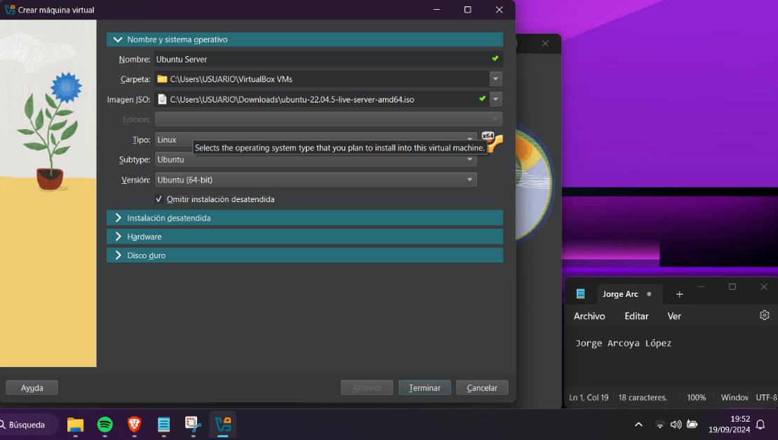Once the screen appears, you will have to choose the name of the virtual machine, the ISO image, if you choose the ISO image, the type, subtype and version of the operating system will be put alone, and in this case I will also check the option 'Skip installation attended', all this within the section of Name and Operating System, as indicated in Figure 9.

Picture 9 Name and Operative System

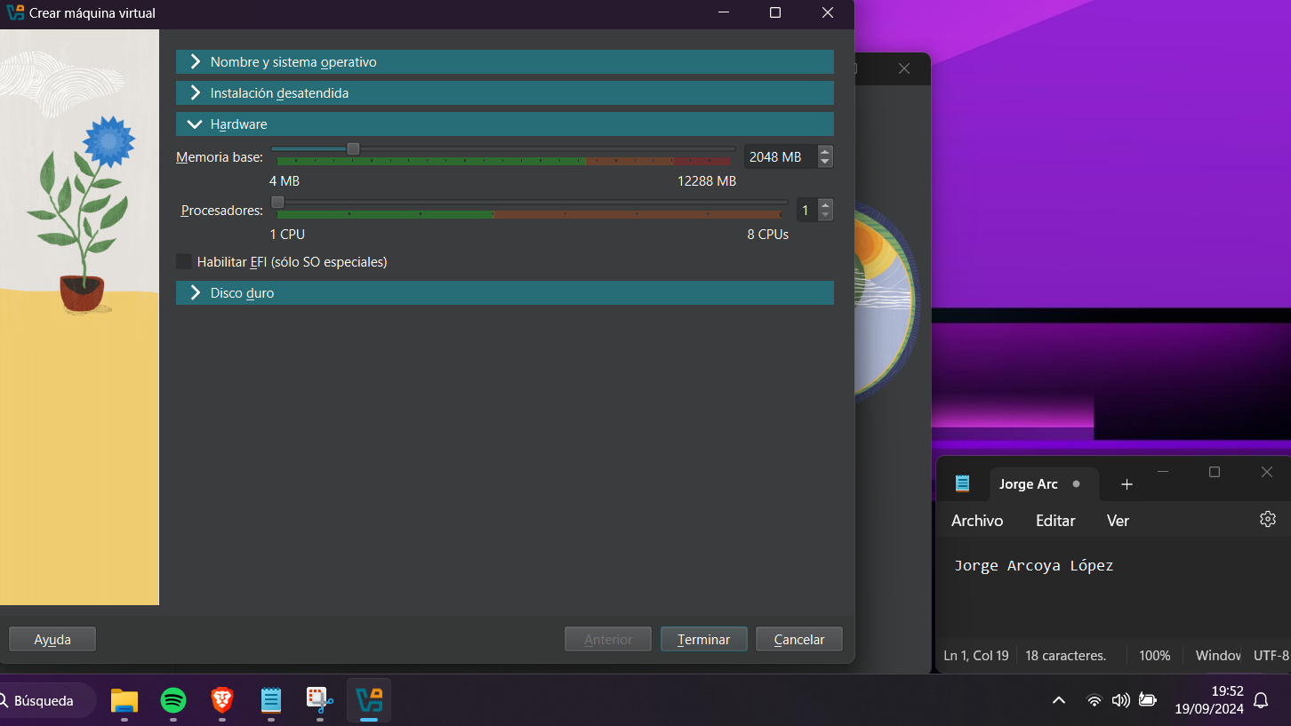On the same page, in the Hardware section, select the base memory that the virtual machine will have and how many processors it will have, as shown in Figure 10.

Picture 10 Hardware

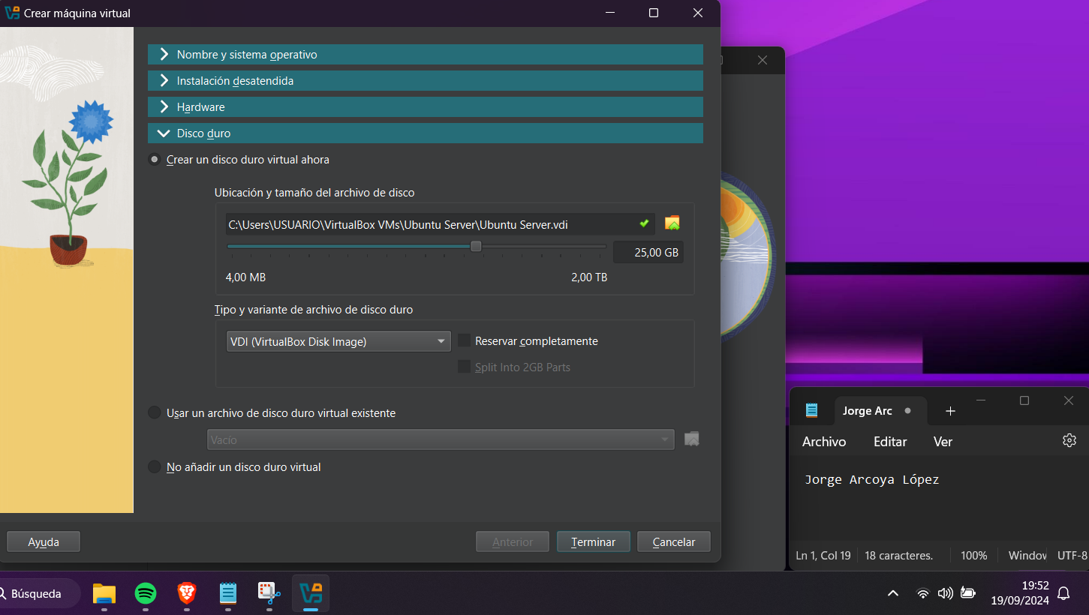Again on the same page but this time in the ‘Hard Disk’ tab you have to put whether to create a new virtual hard disk or use an existing one, if you create it, which is my case, you have to put the capacity of this hard disk, after that you have to click on finish, as it is done in the image 11.

Picture 11 Hard Disk

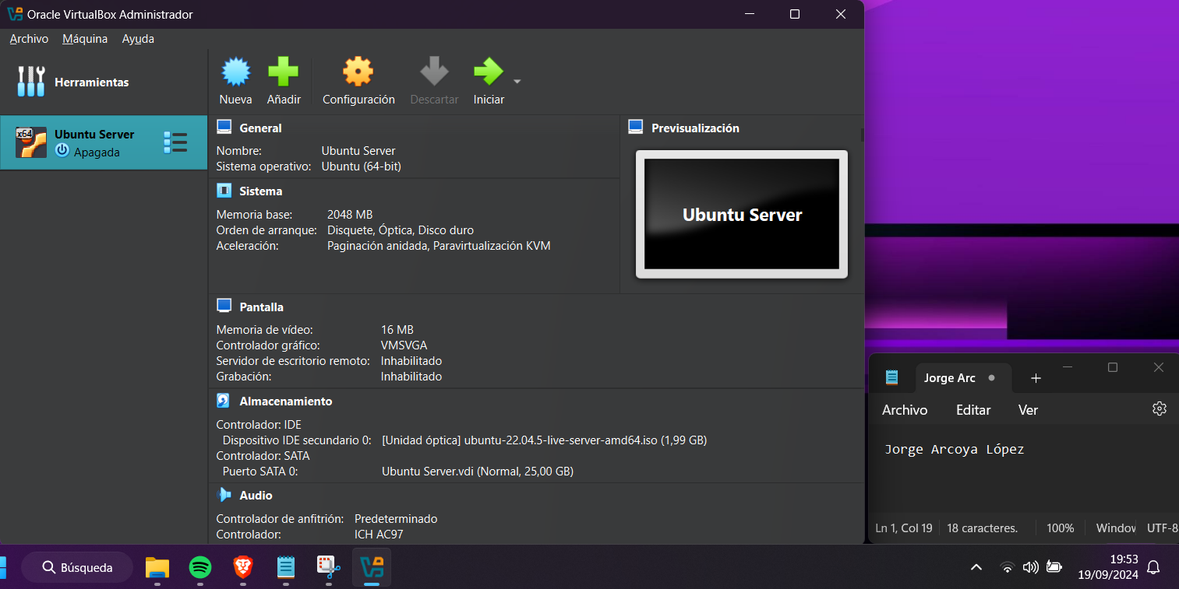Next, and after configuring these parameters, the virtual machine is already created, now to install Ubuntu you have to start it and for that you have to press the green arrow button that is at the top in the middle and that says 'Start'. Figure 12 shows how to do this.

Picture 12 Start virtual machine

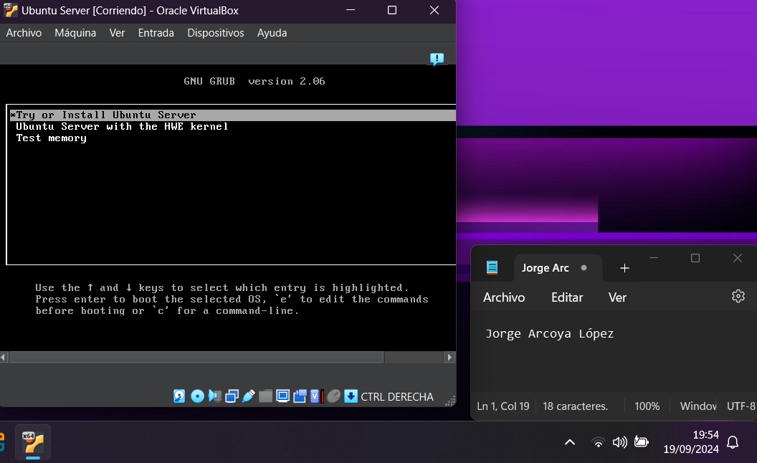When you start the virtual machine, the first thing that appears is the Grub and gives you three options to choose, you have to choose the first one that says 'Try or Install Ubuntu Server', Figure 13 shows how.

Picture 13 Grub

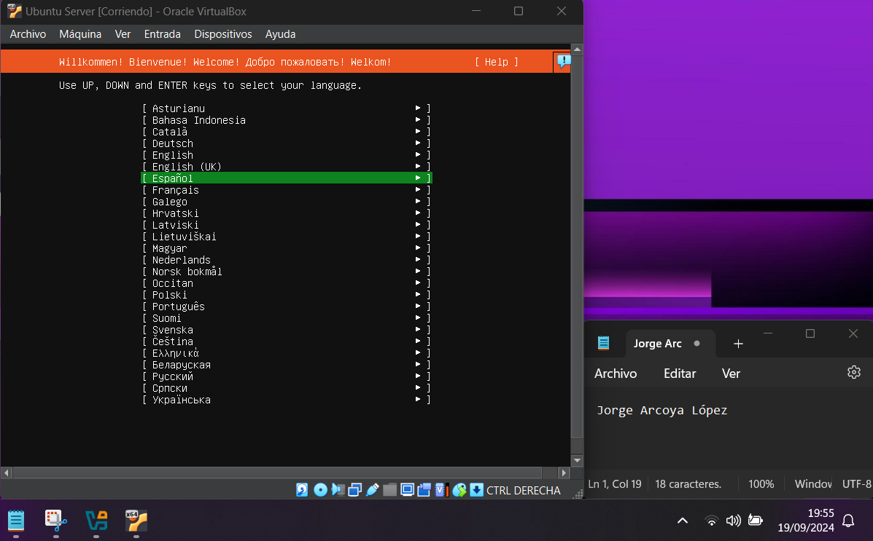When you start to install the Ubuntu server, the first thing you have to do is select the language, in my case Spanish, Figure 14 shows an example

Picture 14 Language

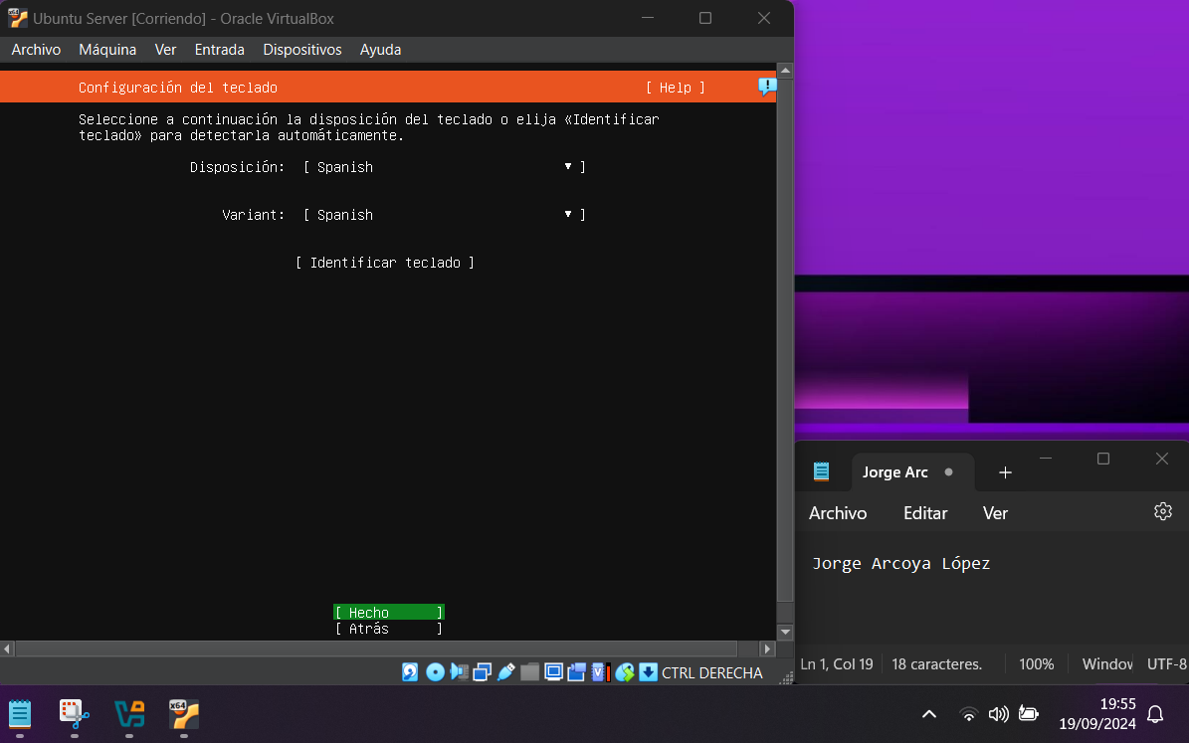After choosing the language you have to choose the keyboard layout you are going to use, in my case it is also Spanish, image 15 shows this process.

Picture 15 Keyboard Layout

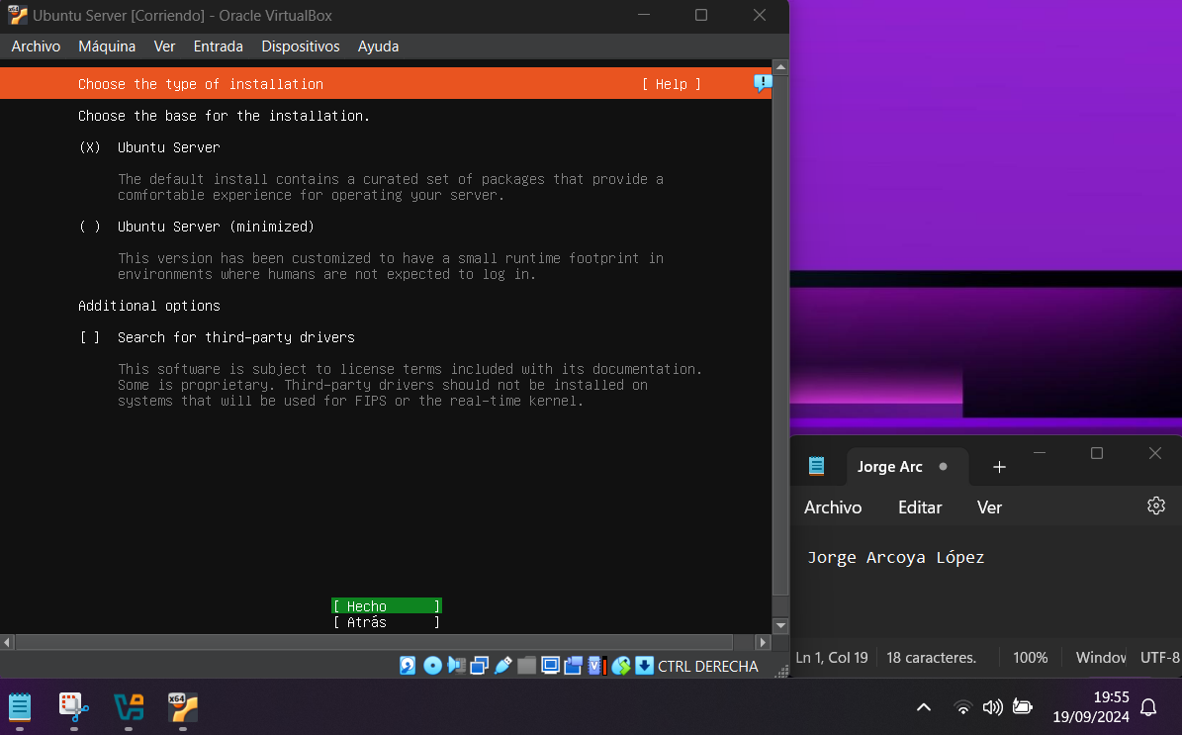Then you have to choose the base for the installation, on this screen you leave the option that comes by default and give it to "Done". Image 16 shows how to do it

Picture 16 Base for the installation

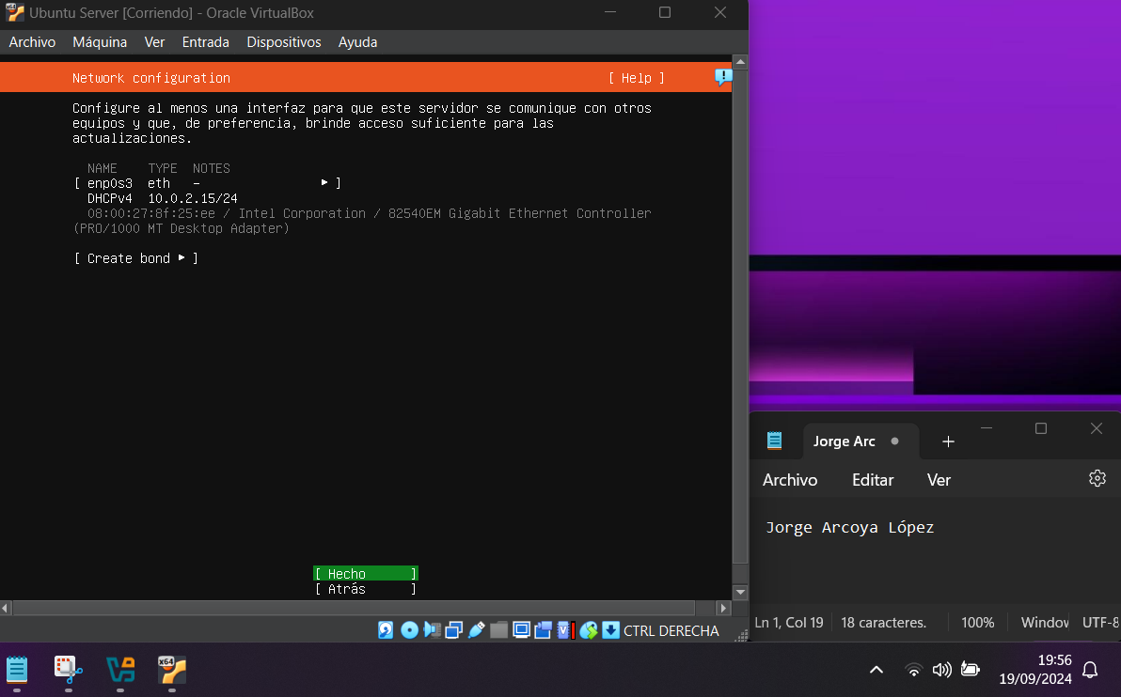On the next page you have to configure an interface for the server to communicate with other servers, again leave the default configuration and click ‘Done’, image 17 shows how to do this.

Picture 17 Netowrk Configuration

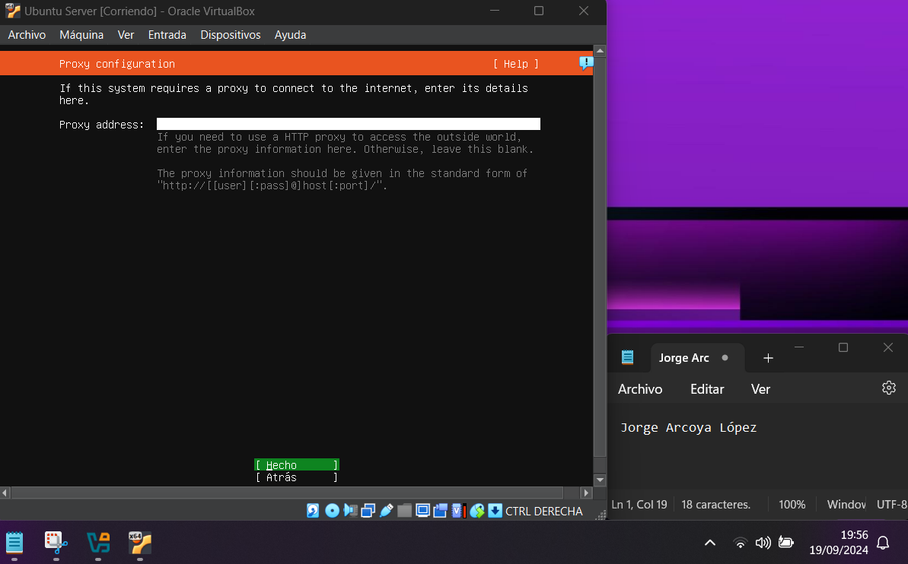The next screen is to configure a proxy but you don't need to configure it, just click on ‘Done’ again, image 18 shows you how to do it.

Picture 18 Proxy Configuration

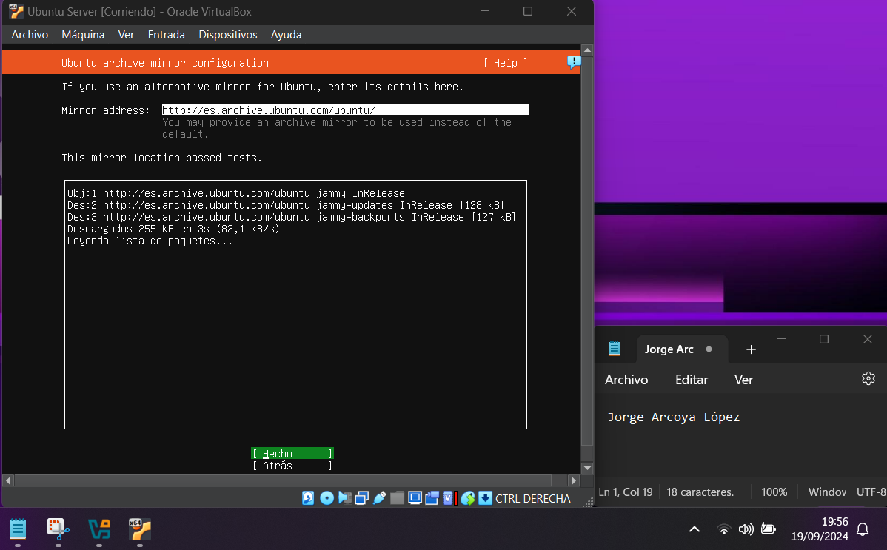The next screen is in case you are using an alternative mirror for Ubutnu, but as this is not the case just hit ‘Done’ again, image 19 shows an example of how to do this.

Picture 19 Mirror configuration

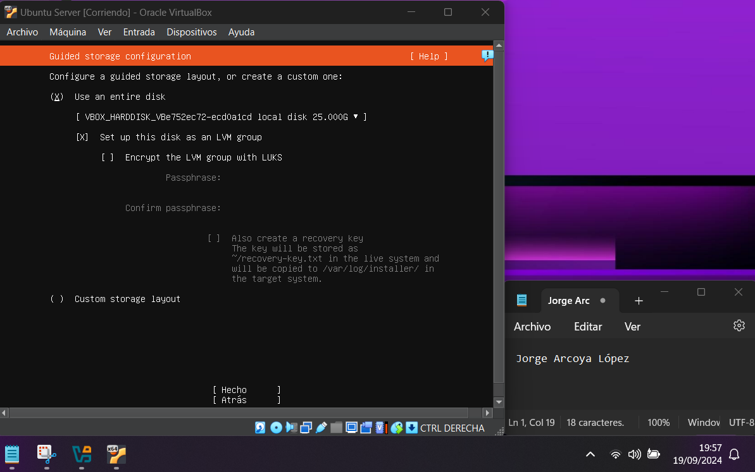Then a screen appears which is useful if you want to configure the storage of the hard disk to be used, as this is not the case, just click on ‘done’ and you're done.

Picture 20 Guided storage configuration

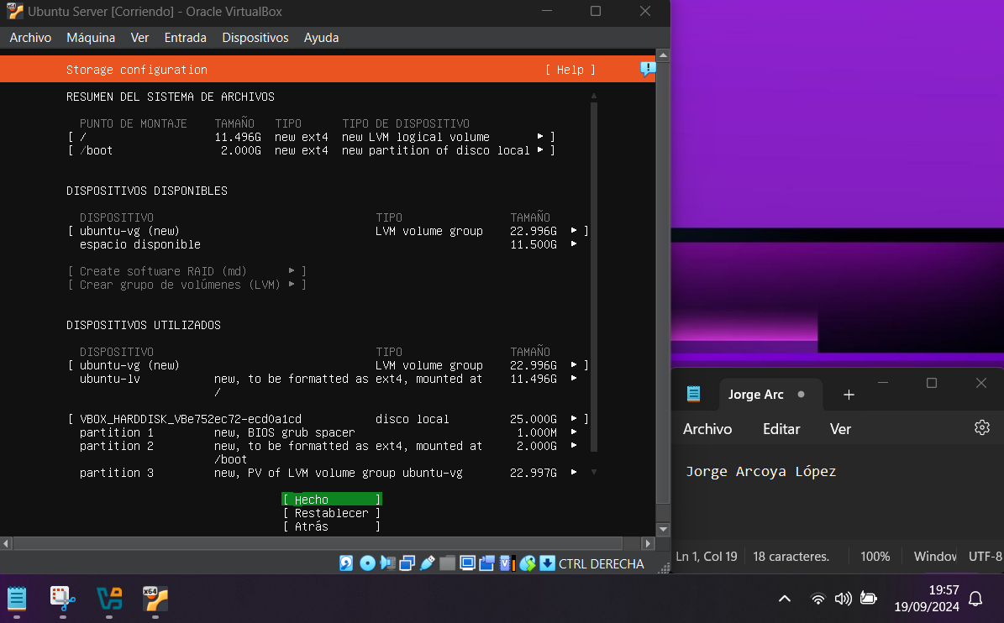The following screen is just a summary of the file system that the Ubuntu server is going to use, again just hit "fact", as shown in image 21.

Picture 21 Storage Configuration

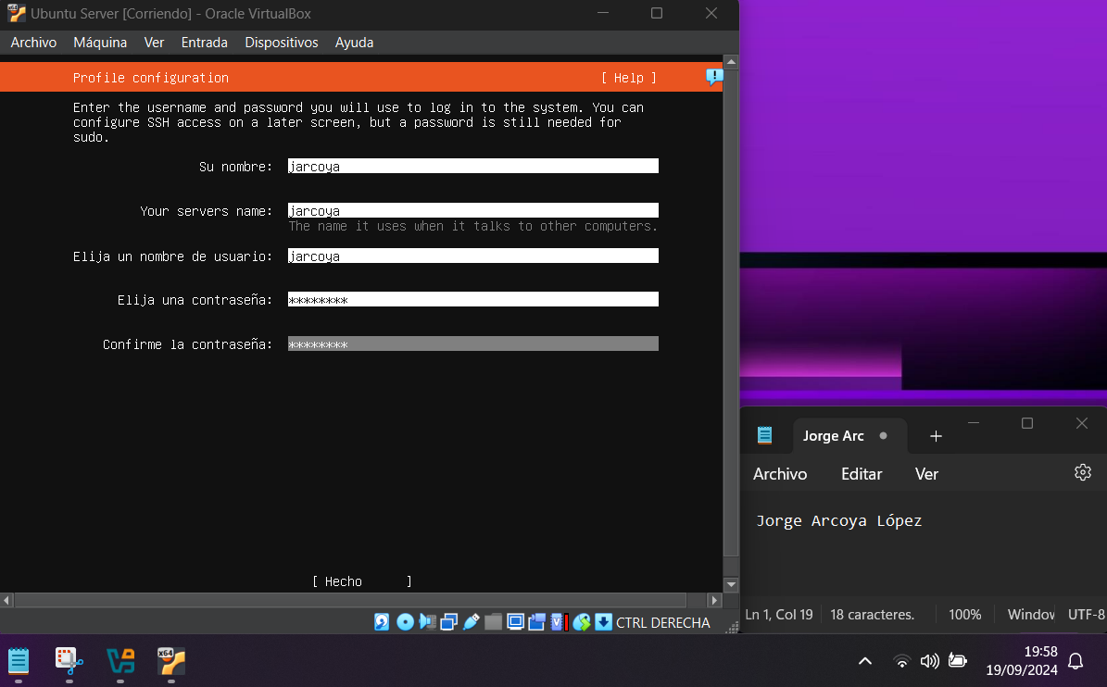After summarizing the file system you have to choose the server name, username and password and once you have chosen to hit "Done", image 22 shows an example.

Picture 22 Profile configuration

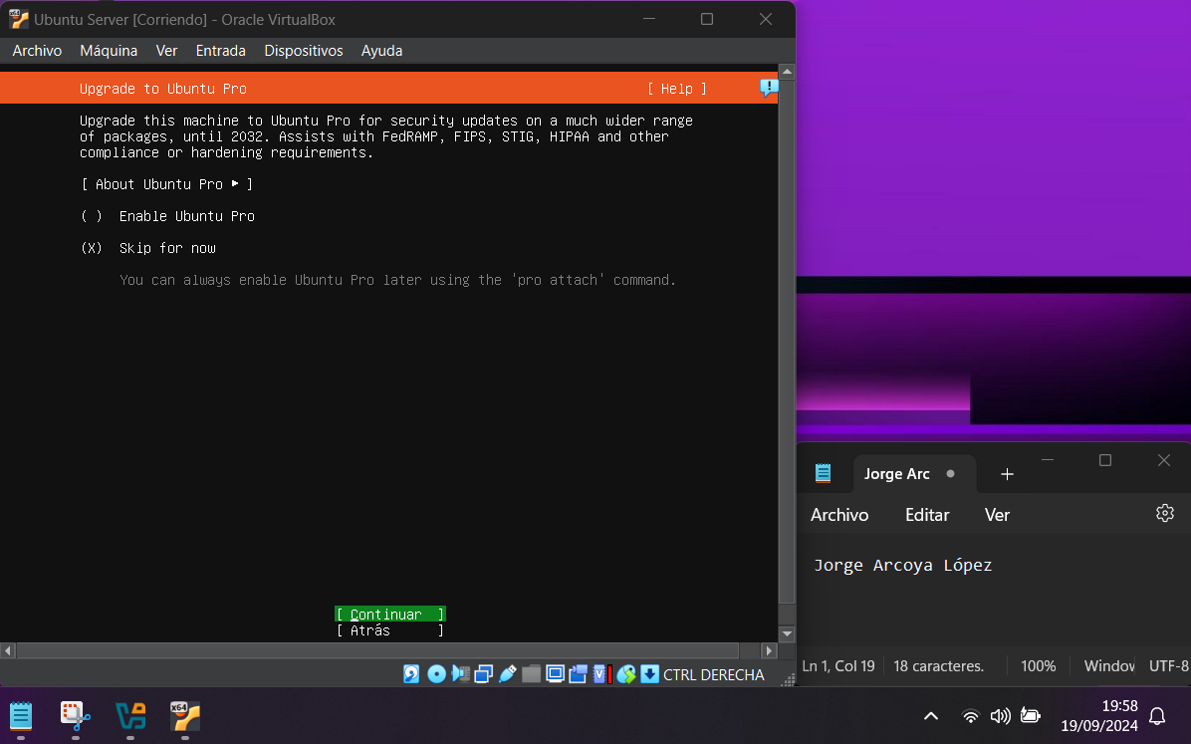Then ask if you want to improve to the Ubuntu Pro but in this case the default option is left which is "Skip for now" and it is given to "done", image 23 shows you how to do it.

Picture 23 Upgrade to Ubuntu Pro

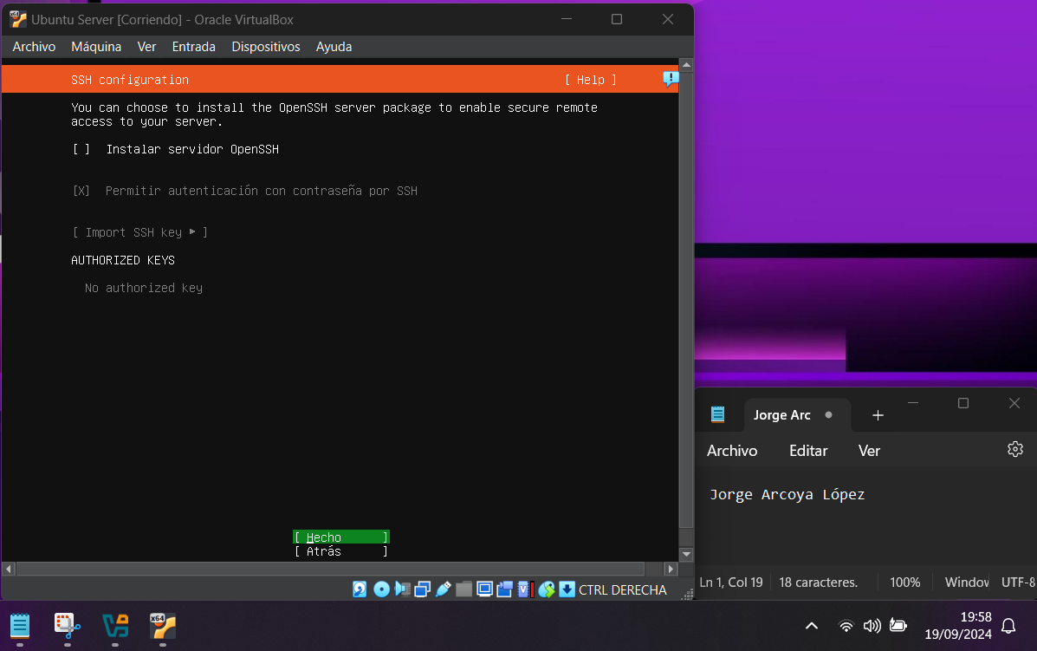The next screen tells you if you want to install the OpenSSH server, in my case I have not checked the option and I have hit "Done", as shown in image 24.

Picture 24 SSH Configuration

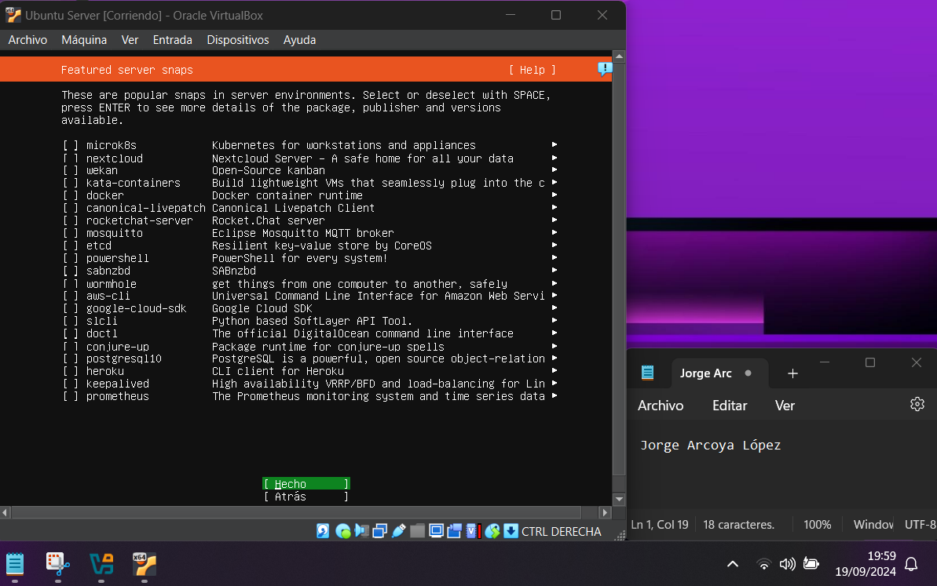After that, a screen appears telling you if you want to install several popular snaps in the server environments, in my case I haven't checked any and just hit "Done", image 25 shows you this process.

Picture 25 Feature server snaps

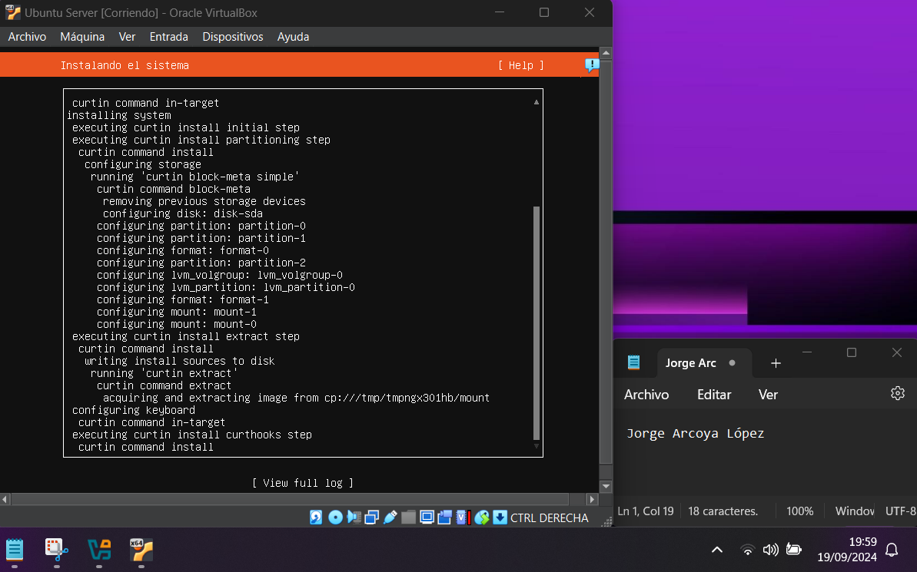After configuring all these parameters, the installation starts and then you just have to wait for it to finish as seen in image 26.

Picture 26 System Installation

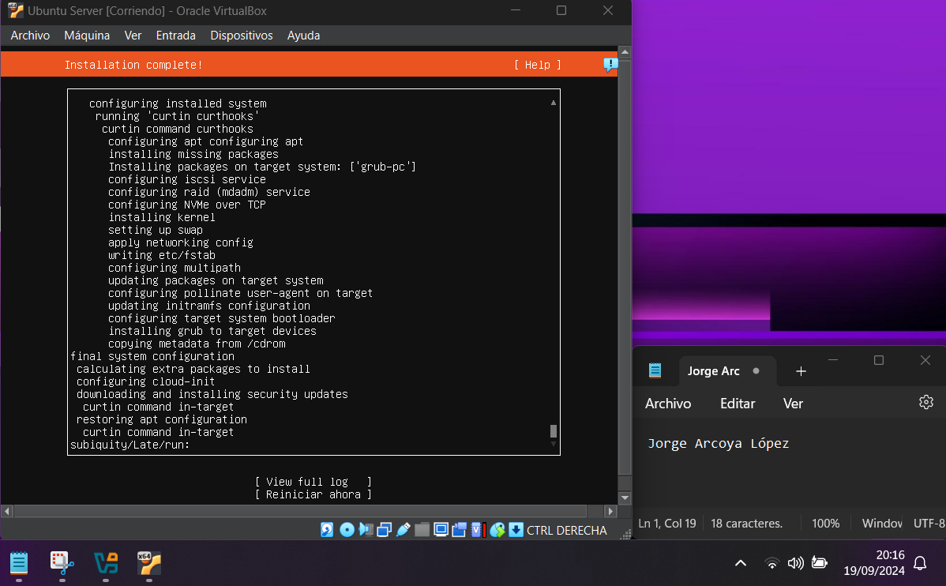Once the system has finished installing, you just have to click on the option that says "restart now" as shown in image 27.

Picture 27 Installation Complete

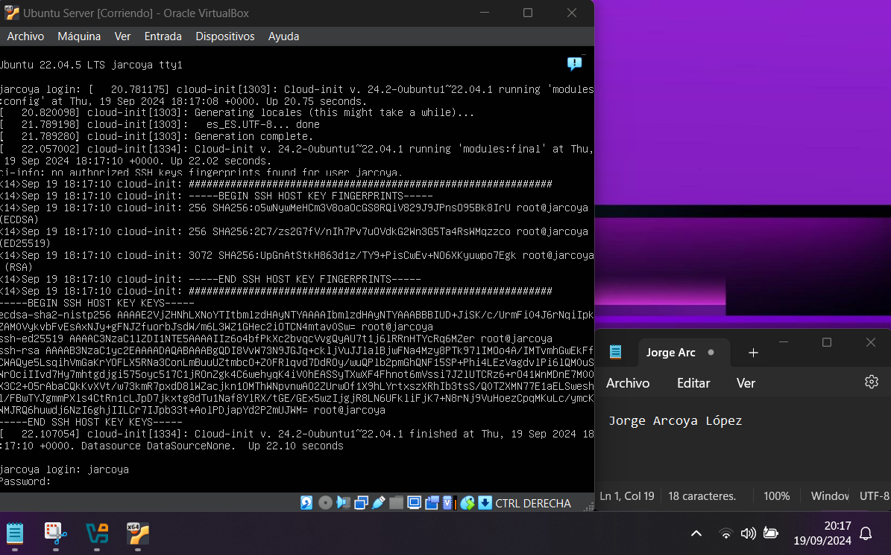When it finishes rebooting, the Ubuntu Server is ready to use as seen in image 28.

Picture 28 Ubuntu already installed

Installation of the Graphical Interface

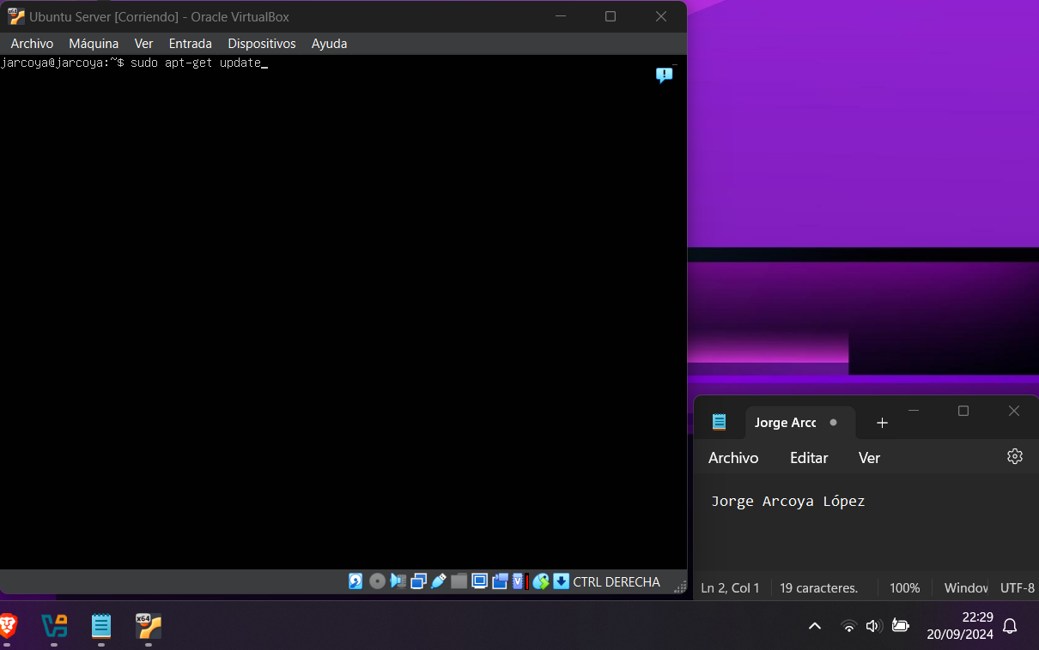o install the Ubuntu graphical interface the first thing to do is to run the command "sudo apt-get update" so that the packages are updated, image 29 shows how to do it.

Picture 29 Update packages

After updating the packages you have to use the command "sudo apt upgrade" that is used to update the installed packages, in image 30 you can see how to use the command.

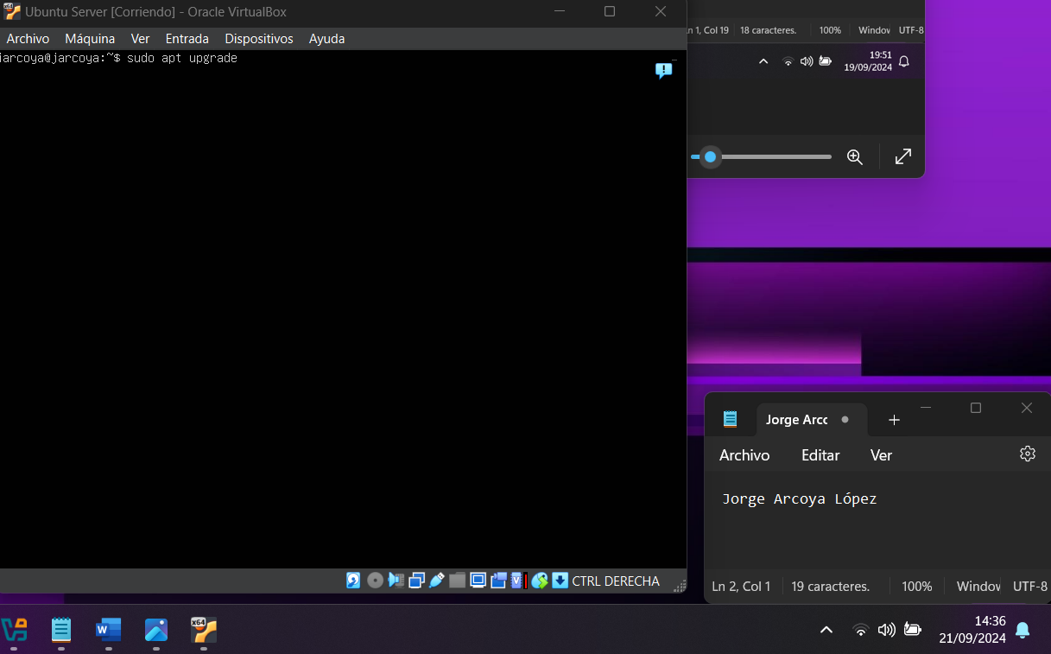

Picture 30 Update installed packages

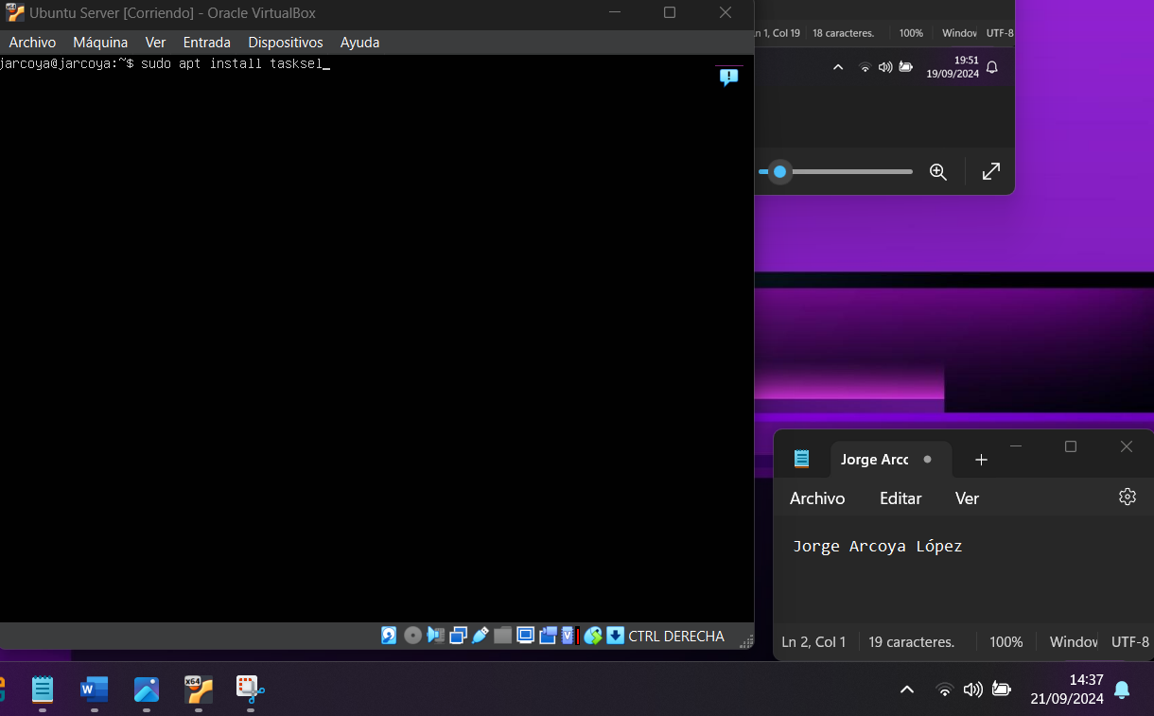After updating all the packages you have to install the "tasksel" to be able to install the graphical interface and for this you use the command "sudo apt install tasksel", image 31 shows how to install the tasksel.

Picture 31 Install tasksel

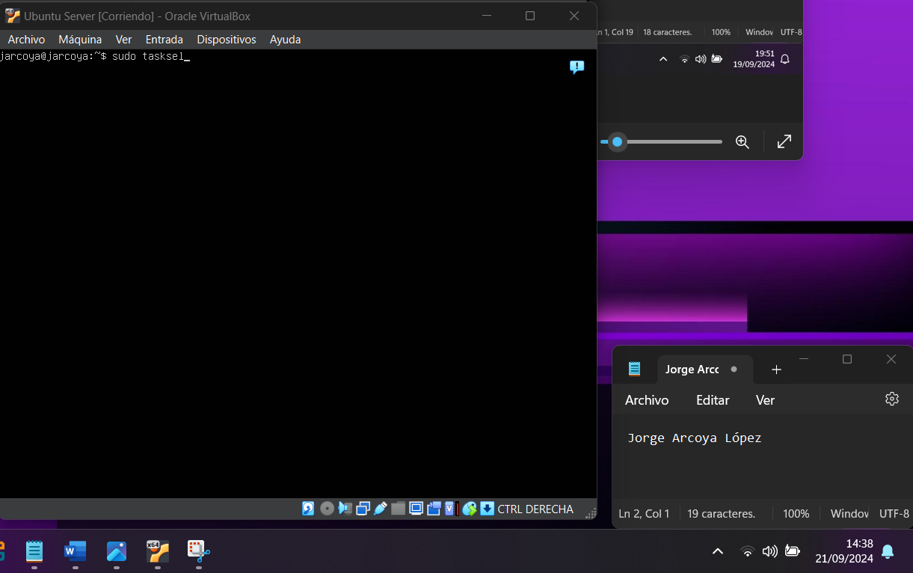To run the tasksel and be able to install the graphical interface, you have to use the command "sudo tasksel" as shown in image 32.

Picture 32 Use tasksel

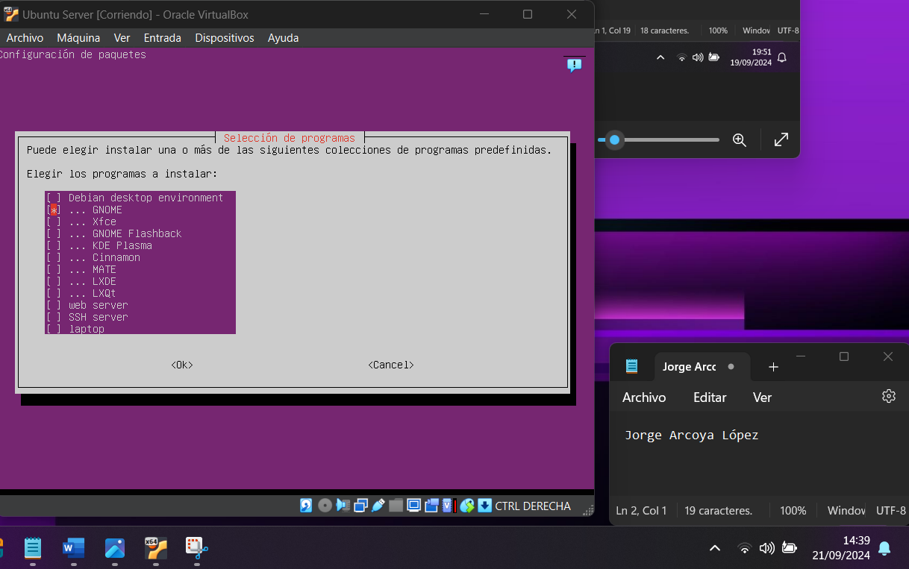After using the previous command, a panel opens where you have to choose the graphical interface to install, choose with the space and then click on the tab and "ok", image 33 shows how to do it.

Picture 33 Choose the graphical interface

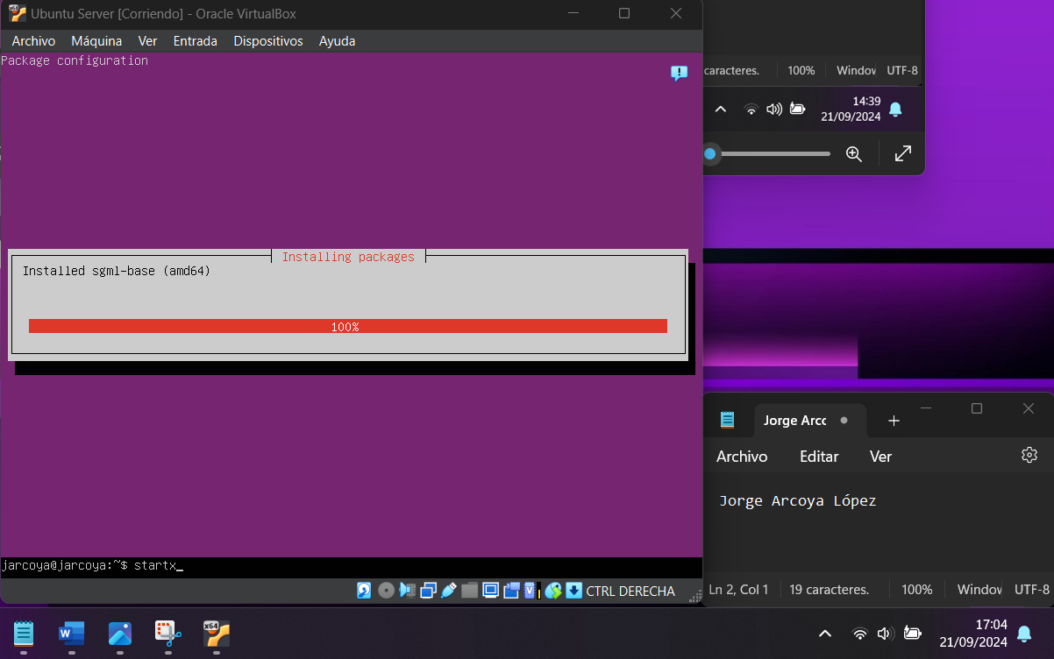Once you have chosen the interface, it starts to be installed and then you just have to let it be installed as shown in image 34.

Picture 34 graphical interface being installed

When you finish installing you only have to do one more thing and that is to execute the command "startx" on the command line and the graphical interface will open, image 35 shows you this process.

Picture 35 Run graphical interface

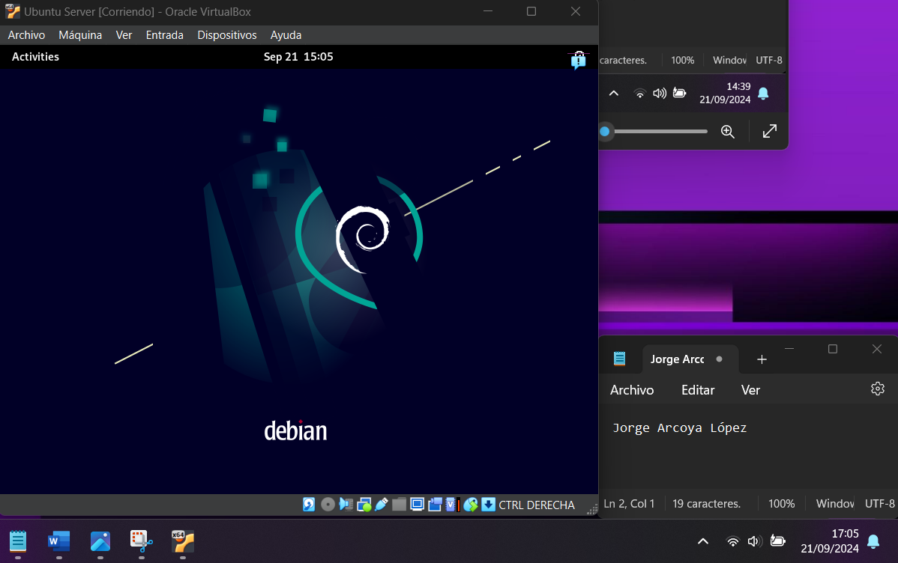Running the command opens the graphical interface you have chosen, as seen in Figure 36.

Picture 36 Graphical Interface

Bibliografía

VirtualBox --- <https://www.virtualbox.org/wiki/Downloads>

Ubuntu Server --- <https://ubuntu.com/download/server>